חומר פתוח תקשורת

Osi tcp/ip

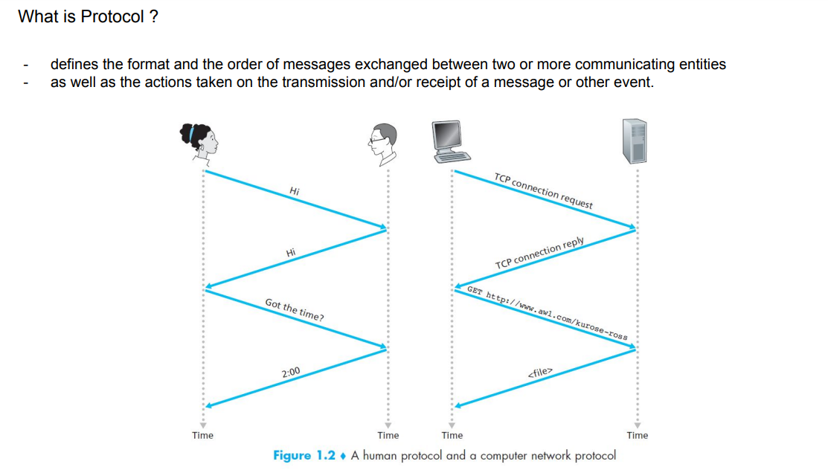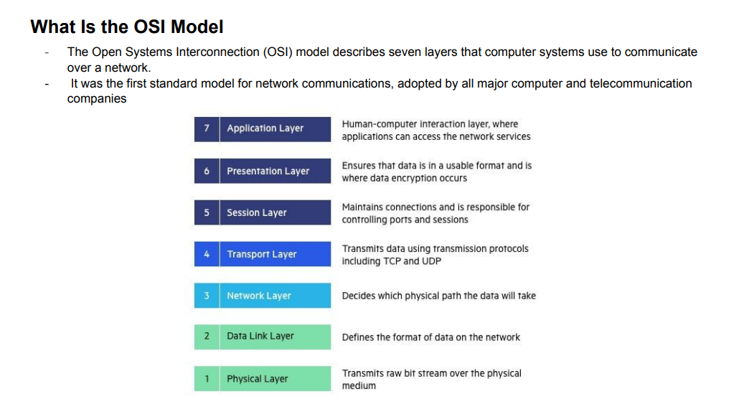

**Application** **Layer** - The application layer is used by end-user software such as web browsers and email clients. - It provides protocols that allow software to send and receive information and present meaningful data to users. - A few examples of application layer protocols are the Hypertext Transfer Protocol (HTTP), File Transfer Protocol (FTP), Post Office Protocol (POP), Simple Mail Transfer Protocol (SMTP), and Domain Name System (DNS(

**Presentation** Layer - The presentation layer prepares data for the application layer. - It defines how two devices should encode, encrypt, and compress data so it is received correctly on the other end. - The presentation layer takes any data transmitted by the application layer and prepares it for transmission over the session layer

**Session** Layer - The session layer creates communication channels, called sessions, between devices. - It is responsible for opening sessions, ensuring they remain open and functional while data is being transferred, and closing them when communication ends. - The session layer can also set checkpoints during a data transfer—if the session is interrupted, devices can resume data transfer from the last checkpoint.

**Transport** Layer - The transport layer takes data transferred in the session layer and breaks it into “segments” on the transmitting end. - It is responsible for reassembling the segments on the receiving end, turning it back into data that can be used by the session layer. - The transport layer carries out flow control, sending data at a rate that matches the connection speed of the receiving device, and error control, checking if data was received incorrectly and if not, requesting it again.

**Network** Layer - The network layer has two main functions. - One is breaking up segments into network packets, and reassembling the packets on the receiving end. - The other is routing packets by discovering the best path across a physical network. - The network layer uses network addresses (typically Internet Protocol addresses) to route packets to a destination node.

**Data Link Layer** - The data link layer establishes and terminates a connection between two physically-connected nodes on a network. - It breaks up packets into frames and sends them from source to destination. - Logical Link Control (LLC), which identifies network protocols, performs error checking and synchronizes frames. - Media Access Control (MAC) which uses MAC addresses to connect devices and define permissions to transmit and receive data.

**Physical** Layer - The physical layer is responsible for the physical cable or wireless connection between network nodes. - It defines the connector, the electrical cable or wireless technology connecting the devices, and is responsible for transmission of the raw data, which is simply a series of 0s and 1s, while taking care of bit rate control.

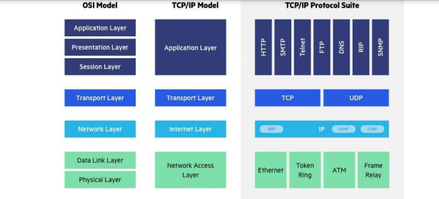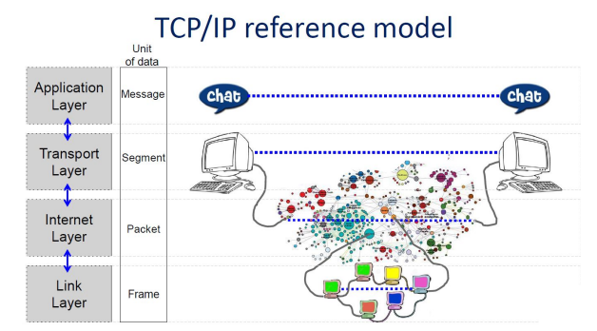

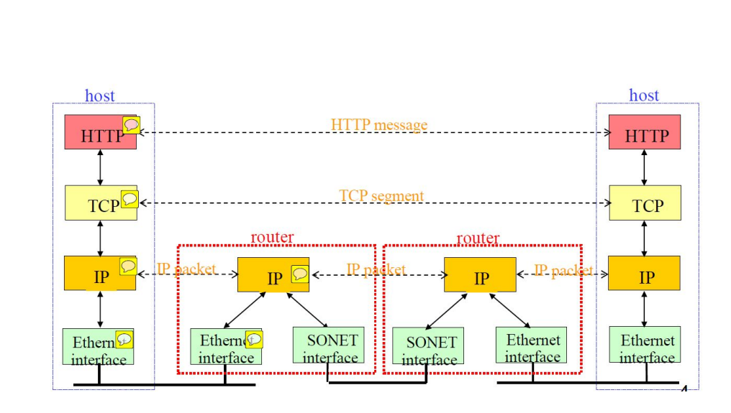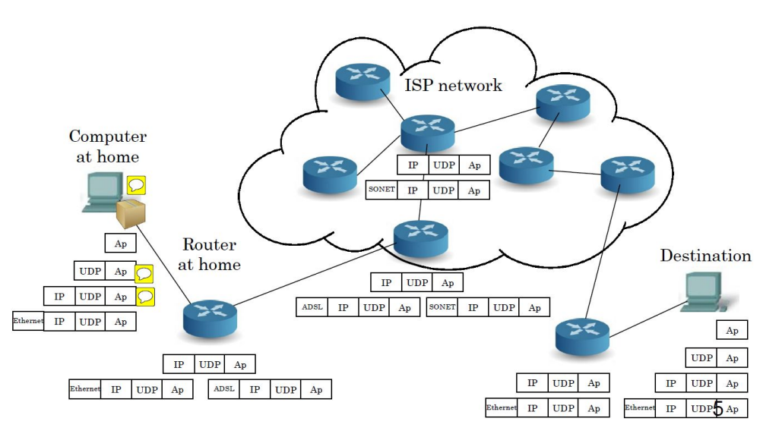

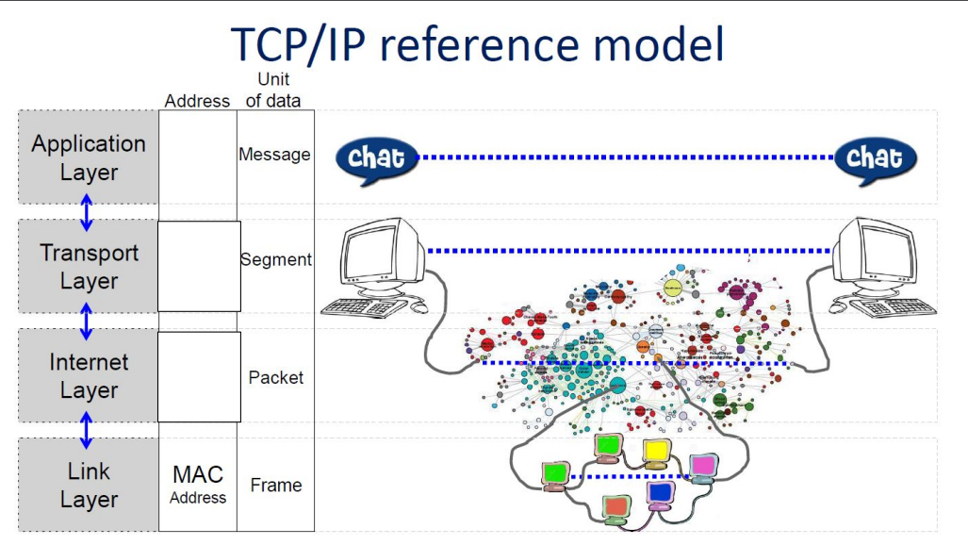mac address: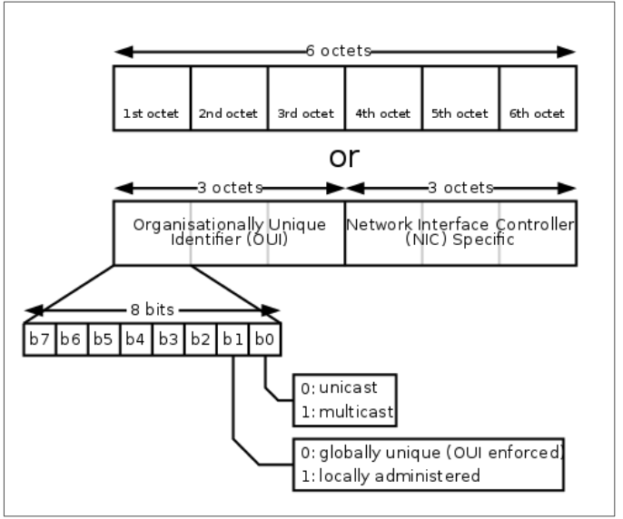

Finding the MAC Address on computer (laptops or desktops) - Windows: 1. Press both the Windows Key and the R key simultaneously. 2. Type ncpa.cpl into the search box and press ENTER. 3. Right-click your Local Area Connection or Wi-Fi Connection (depending on how you are connected) and select Status. 4. Click Details and the Physical Address is your MAC Address. Or----------- 1. On your computer, search for cmd.exe and open this program. 2. On the black Command Prompt screen, type: getmac /v 3. This will list all your adapters. The Physical Address is the MAC address

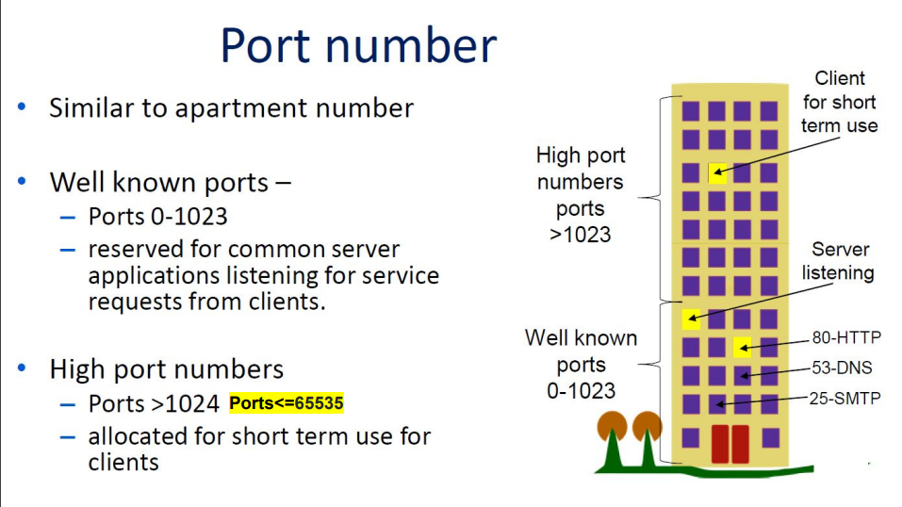

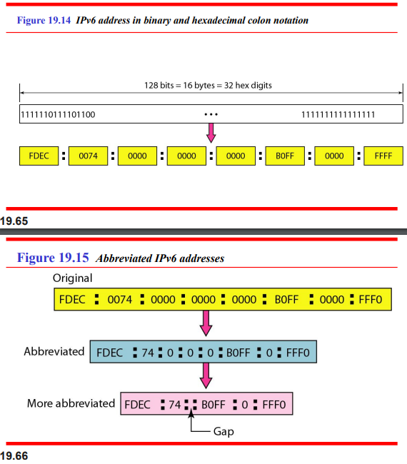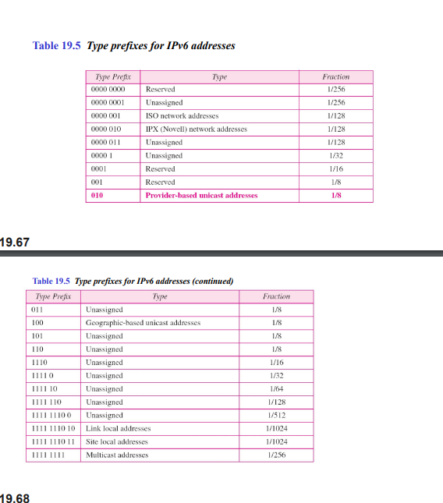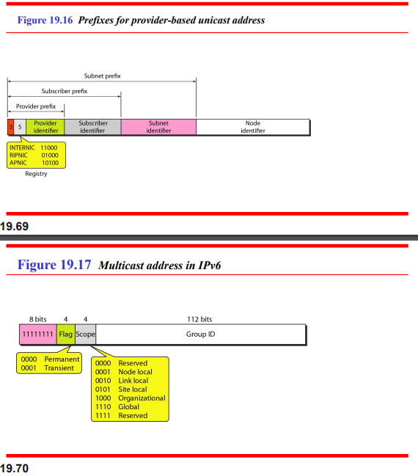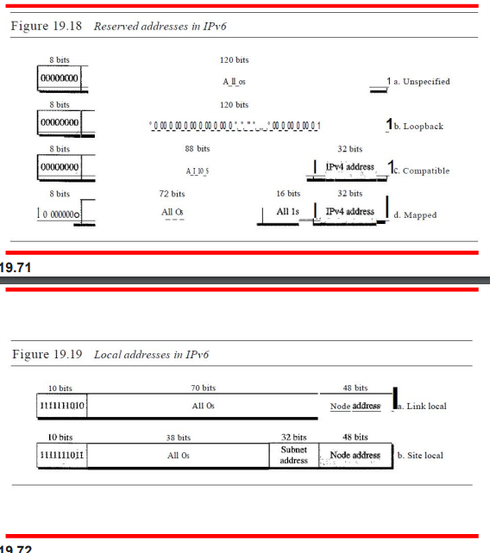

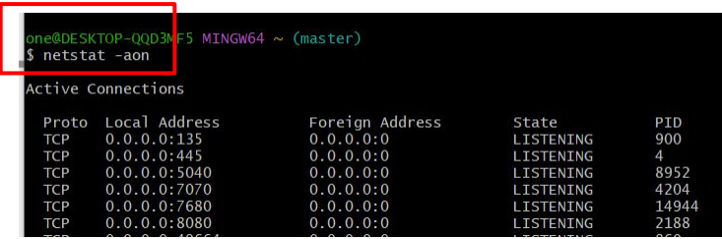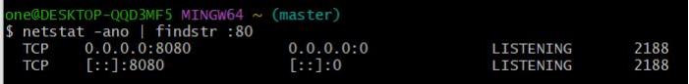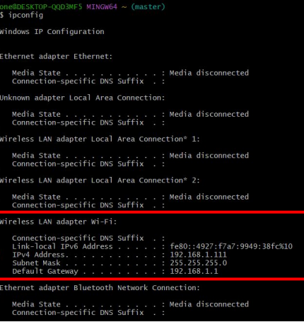

Search ip in terminal. search specific port. Show active connections.

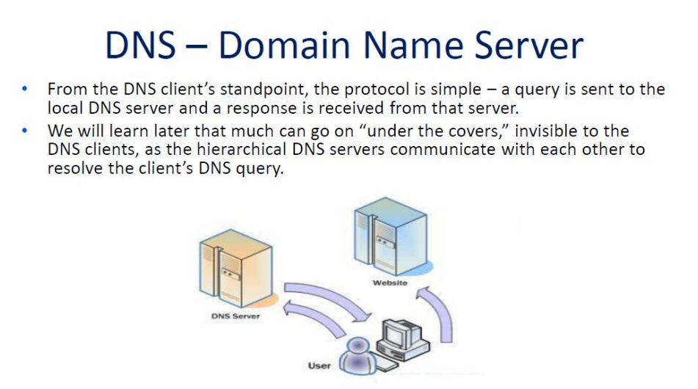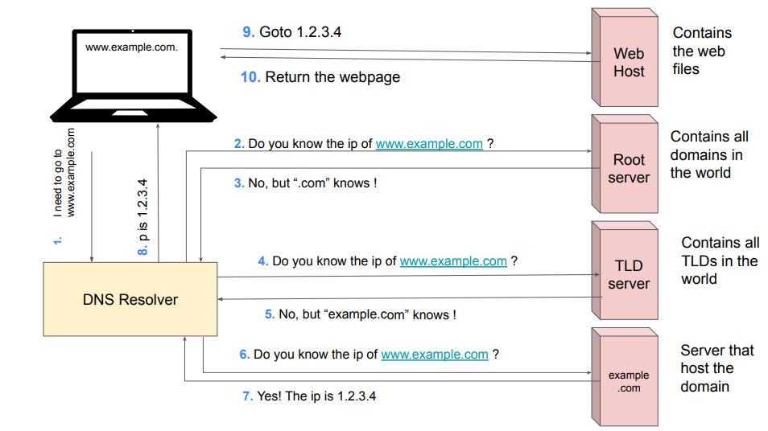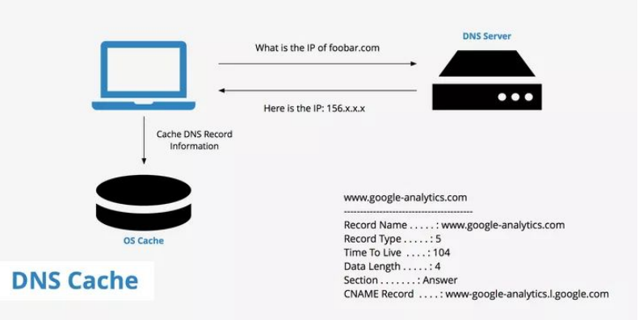

**What is a top-level domain (TLD)?** ● Represents the first stop after the root zone. ● In simpler terms, a TLD is everything that follows the final dot of a domain name. ● For example, in the domain name ‘google.com’, ‘.com’ is the TLD. ● Some other popular TLDs include ‘.org’, ‘.uk’, and ‘.edu’.

**DNS Caching** ● The purpose of caching is to temporarily stored data in a location that results in improvements in performance and reliability for data requests. ● DNS caching involves storing data closer to the requesting client, so that the DNS query can be resolved earlier and additional queries further down the DNS lookup chain can be avoided ● Can be cached in a variety of locations, each of which will store DNS records for a set amount of time determined by a time-to-live (TTL).

**What is a DNS record?** ● Instructions that live in authoritative DNS servers and provide information about a domain including what IP address. ● Is associated with that domain and how to handle requests for that domain. ● All DNS records also have a ‘TTL’, which stands for time-to-live, and indicates how often a DNS server will refresh that record. ● will give you a bunch of useful information about a business such as their location, hours, services offered, etc. ● All domains are required to have at least a few essential DNS records for a user to be able to access their website using a domain name, and there are several optional records that serve additional purposes.

**What are the most common types of DNS record?** ● A record - The record that holds the IP address of a domain. ● AAAA record - The record that contains the IPv6 address for a domain (as opposed to A records, which list the IPv4 address). ● CNAME record - Forwards one domain or subdomain to another domain, does NOT provide an IP address. ● MX record - Directs mail to an email server. ● TXT record - Lets an admin store text notes in the record. These records are often used for email security. ● NS record - Stores the name server for a DNS entry. ● SOA record - Stores admin information about a domain.

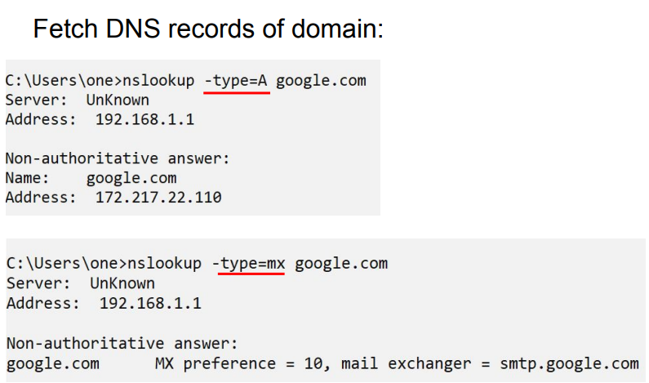

DHCP- dynamic host configuration protocol.

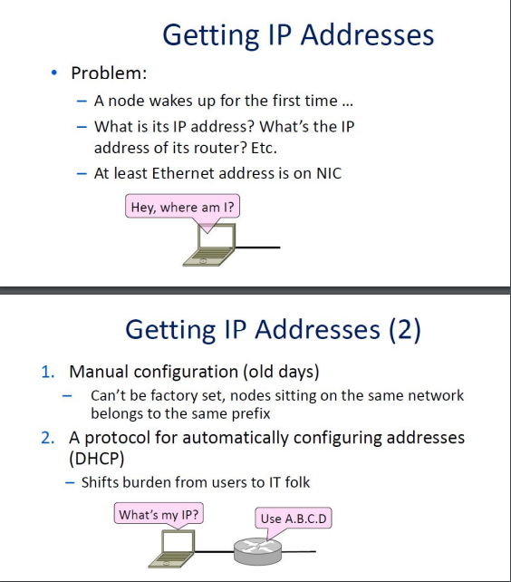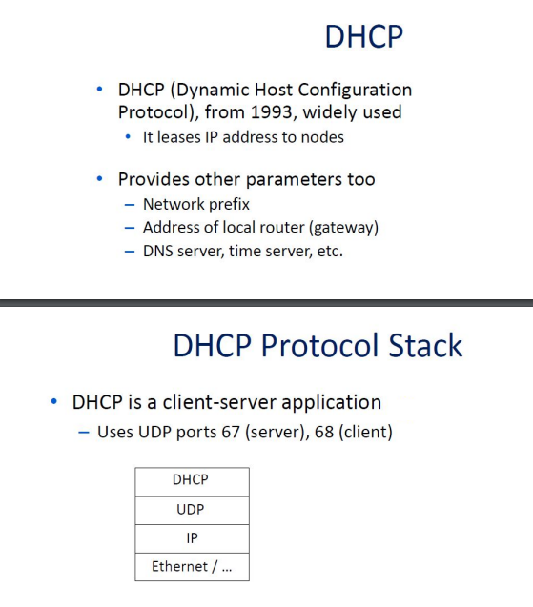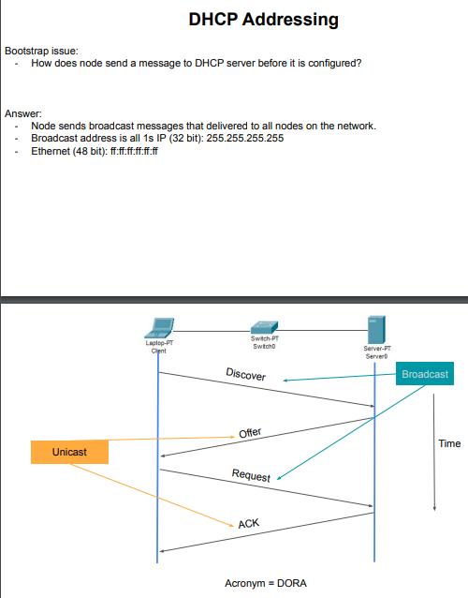To renew an existing lease, an abbreviated sequence is used: - REQUEST, followed by ACK Protocol also supports replicated servers for reliability(request is broadcast, so servers are informed whose offer the client has accepted.)

ARP -Address Resolution Protocol

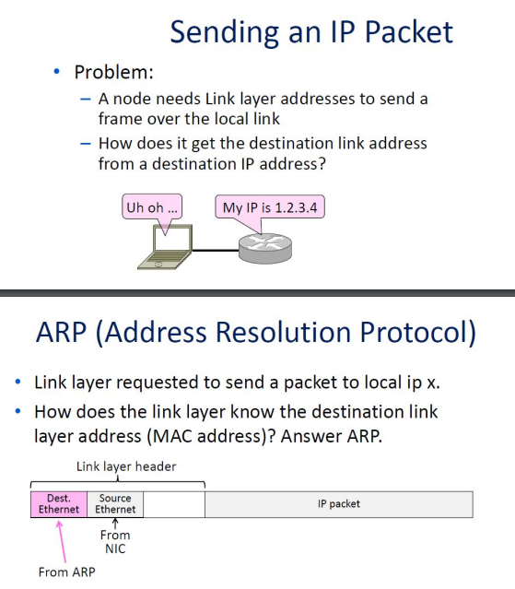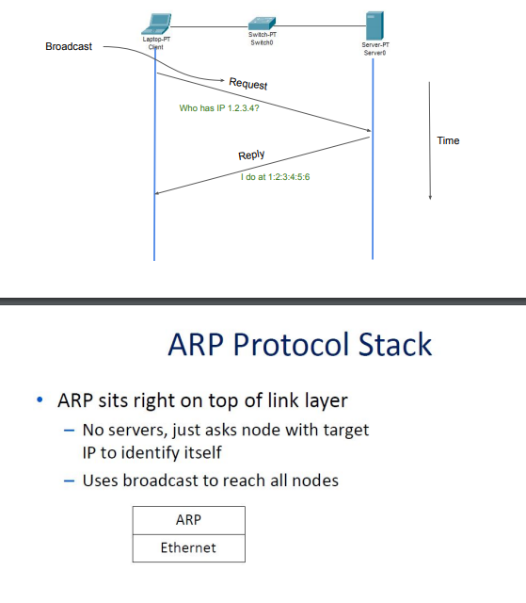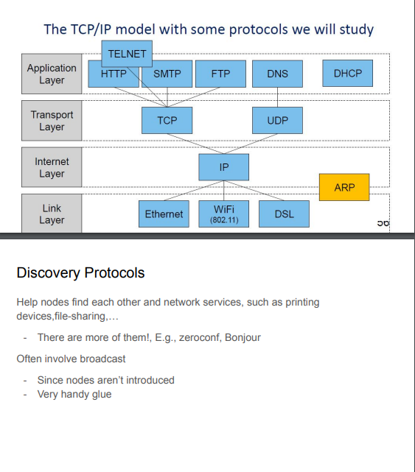

Application layer-related.

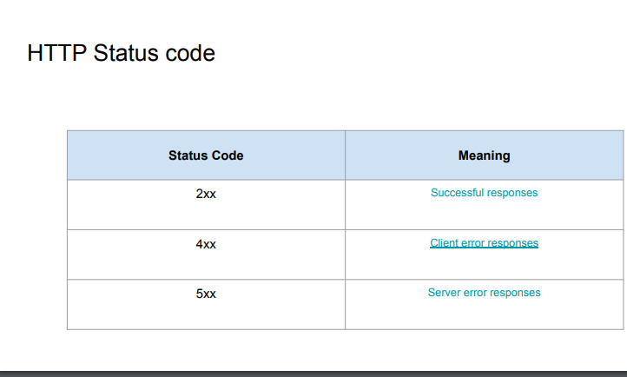

**FTP** - Communication protocol used for the transfer of computer files from a server to a client on a computer network. - Enables users to upload, download, and manage files on a remote server over a TCP/IP network, such as the internet.

**FTP - client server** - Built on a client–server model architecture using separate control and data connections between the client and the server. - The client can then authenticate itself using a username and password and establish a data connection with the server. - Once the connection is established, the client can perform various operations such as uploading files to the server, downloading files from the server, renaming files, deleting files, creating directories, and listing the contents of directories on the server.

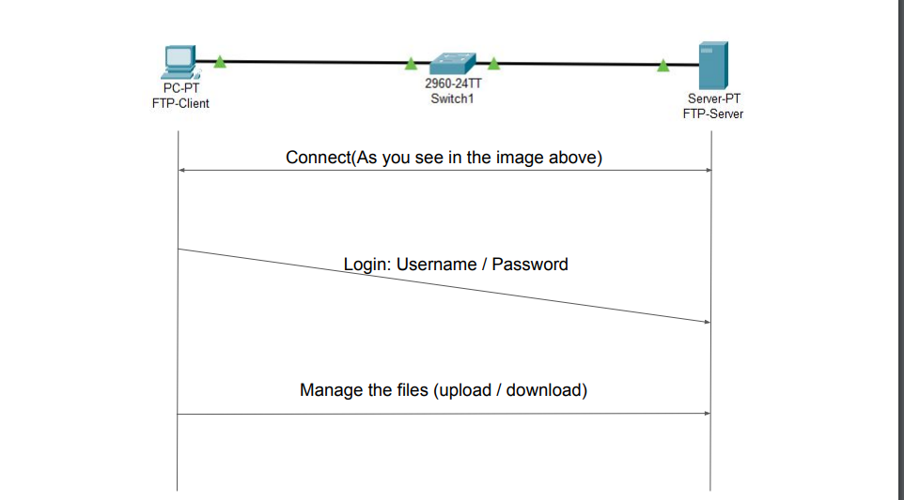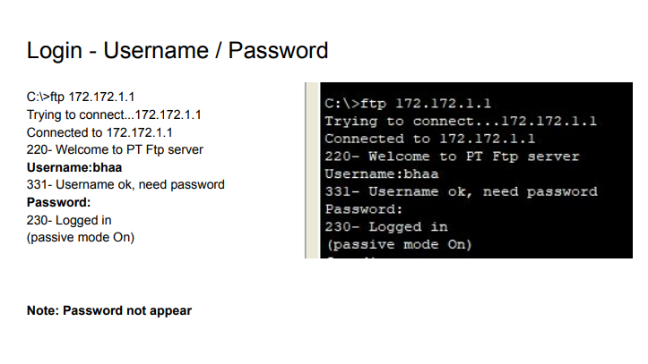 ---see all files🡺 ftp>dir --- upload file🡺put --- download file 🡺 get

**Client server:**

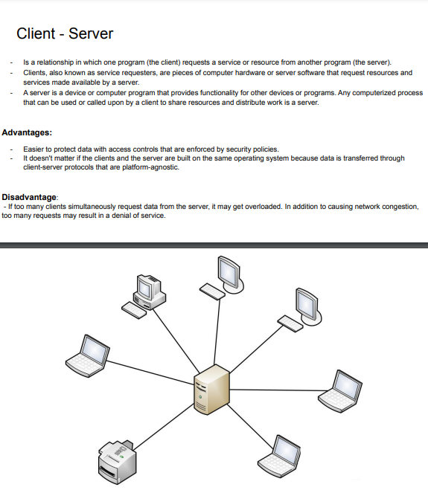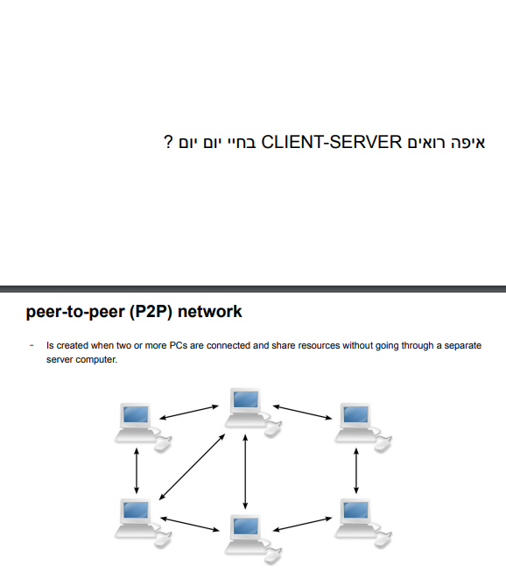

**Hosting:**

**Host** - A host is a computer or other device that communicates with other hosts on a network. - Main role send or receive data, services and applications. - Host requires an IP address.

**Web host** - A host is a web server that stores and transmits the data for one or more websites.

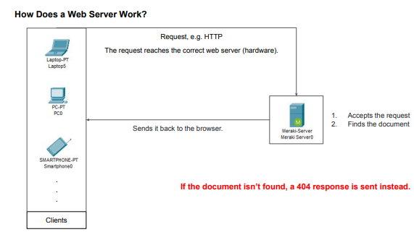

**The Difference Between a Static & Dynamic Web Server** To publish a website, you need a static or dynamic web server. Static Web Server: - comprises a computer (hardware) and an HTTP server (software). - the server sends your browser the hosted files as-it-is. - These websites are the easiest to set up and great for first-time sites. Dynamic Web Server - is a static web server with added software – typically an application server and a database. - the app server renews the hosted files before sending the content to a browser via the HTTP server

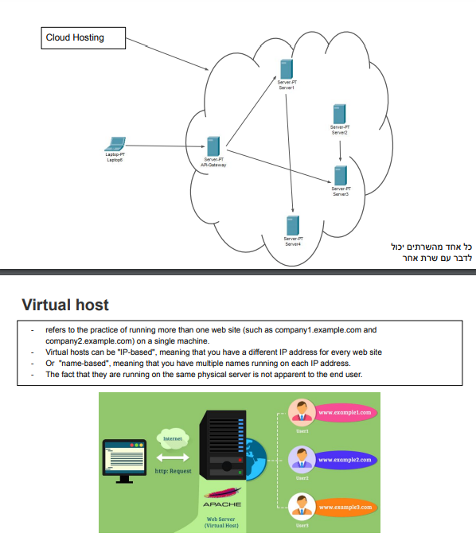 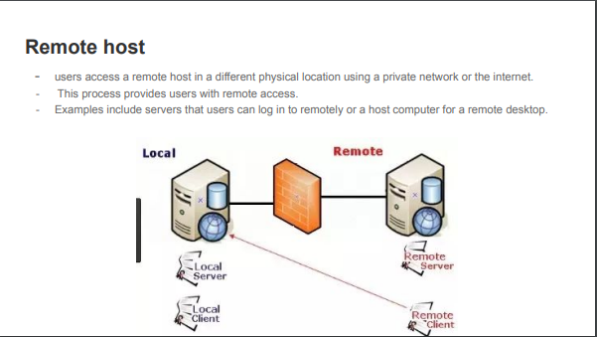

**mail**

**What is a mail server?** - A mail server (sometimes called an email server) is a software program that sends and receives email. - Often, it is used as a blanket term for both mail transfer agents (MTA) and mail delivery agents (MDA). - Mail servers play a crucial role in the email delivery process. - Without them, users would have no way of transferring those messages to and from other mail clients.

**What is a mail client?** - Mail servers send messages from one mail client to another. - A mail client (also called an *email client* or *message user agent*) is a web-based or desktop application that receives and stores email messages. - Some of the most widely-used mail clients include Microsoft Outlook, Gmail, and Apple Mail.

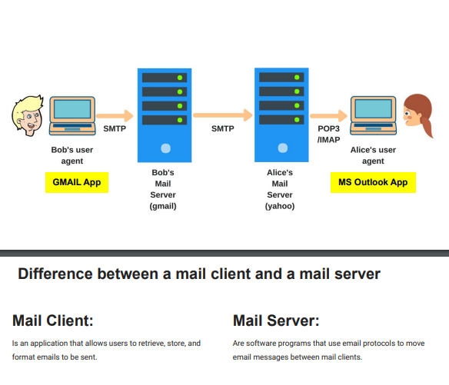

**Switch:**

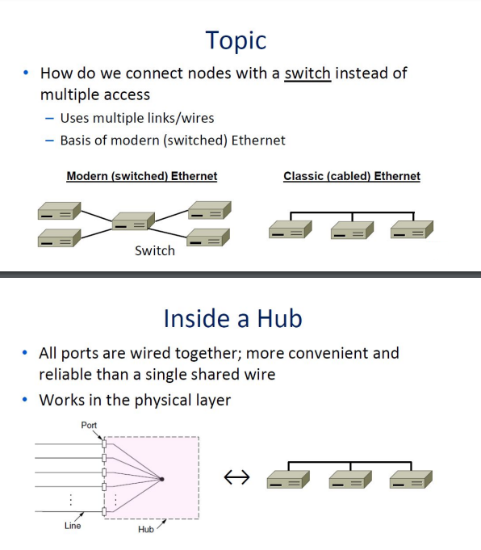 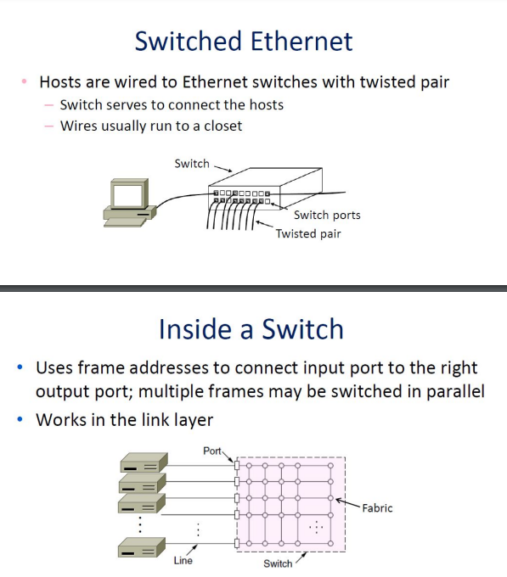 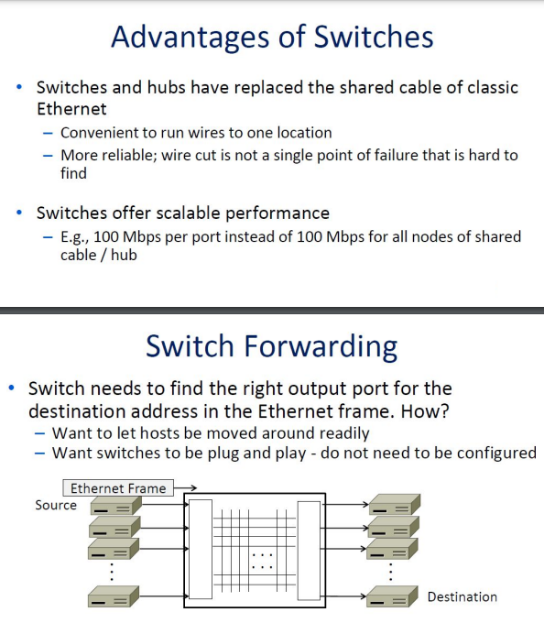

**Firwalls:**

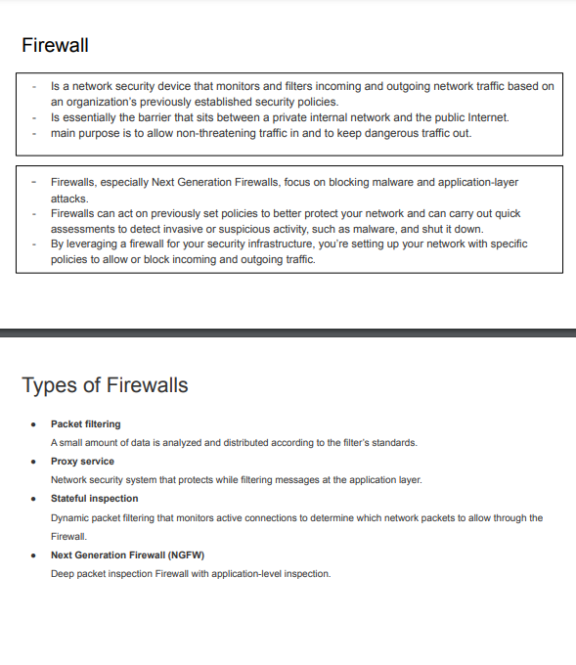

Network topologies:

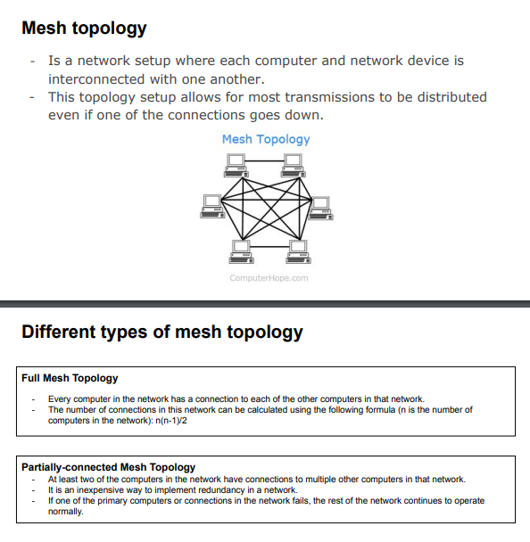 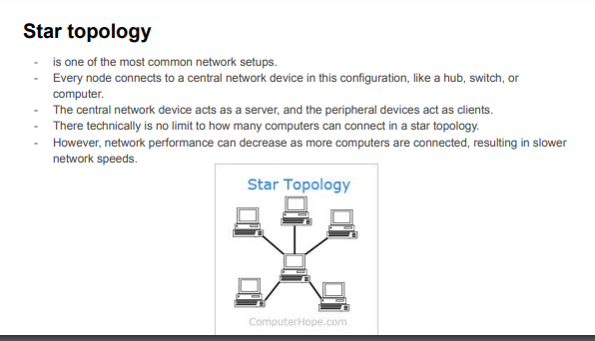 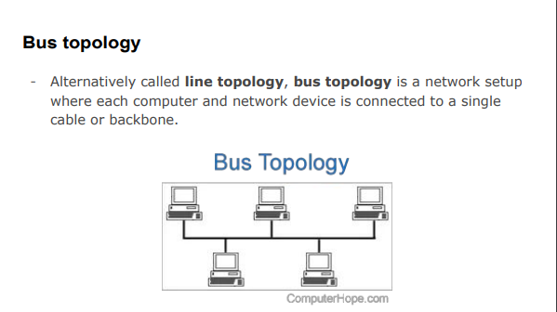

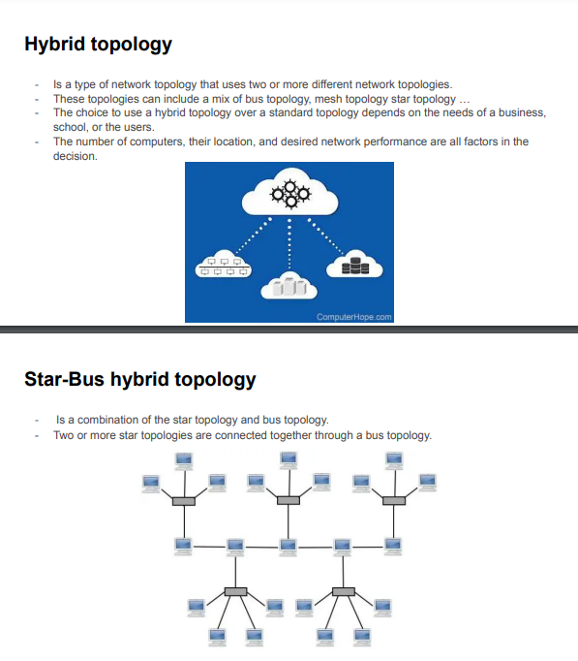

**Computer networks:**

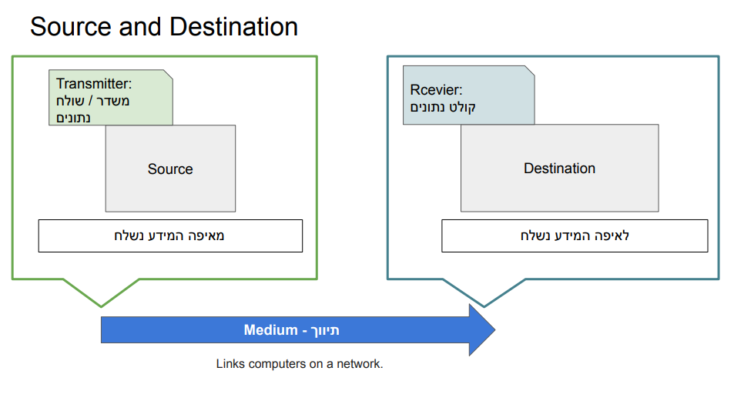

**Signal** ● Process of transmitting and receiving information and data between two or more devices over a computer network. ● The signal may be in the form of electrical or optical waves, or may be encoded using various data transmission protocols such as Ethernet, Wi-Fi, or Bluetooth. ● The goal of signal computer networking is to transmit data efficiently, accurately, and with minimum loss of information.

